**Best Practices**

1. **Lecture series**
2. **Distinguished Lecture Series and other lectures**

**2. Objectives of the practice :**

As a higher educational institution dedicated for research development and innovation, CUK is committed to coordinate activities that illuminate and motivate the student, research and faculty fraternity.

Bringing Nobel laurates and other eminent scholars (through online or offline mode) for lecture and possible interaction with the students can motivate the younger minds for taking up a research career in future. It will also be highly appreciated by the research and faculty fraternity as it can provide updated information on the cutting-edge research and developments that are happening around the world.

**3. The Content :**

**The inaugural lecture** of the Distinguished Lecture Series was by **Prof. Edvard Moser** (**2014 Nobel Prize in Medicine or Physiology**), Director of the Centre for the Biology of Memory, Kavli Institute, Norway on 23rd February 2021 on the topic : “How does the brain deal with space?”. The programme was organised in collaboration with Kerala University of Health Sciences and the talk was well appreciated by the students and faculty members of both CUK and KUHS. A total of 367 students attended the programme and the speaker offered support for all future collaborative research proposals in this direction.

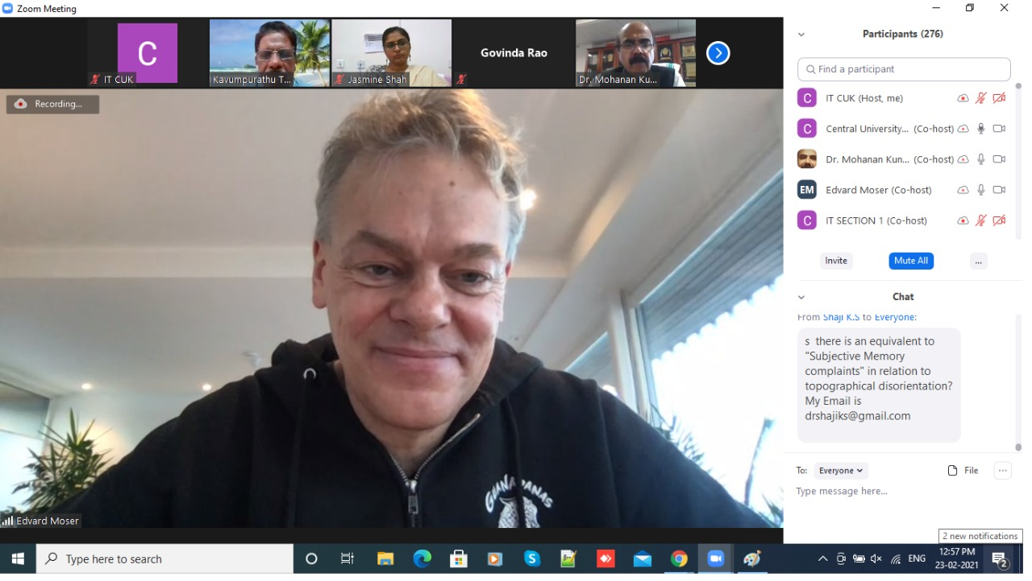

**Second** distinguished lecture was by **Prof. Ramamurthy Ramesh** (**Nominated for Nobel in Physics 2014**), Purnendu Chatterjee Chair, Department of Physics & Department of Materials Science and Engineering, Materials Sciences Division, Lawrence Berkeley National Laboratory, University of California, Berkeley on 10th May, 2021 and the topic was “Magnetic control of ferroelectricity”. 165 participants attended the programme. Prof. Ramesh offered active collaboration with the Department of Physics and Chemistry of CUK including discussions on exchange programmes of students and faculty members of CUK.

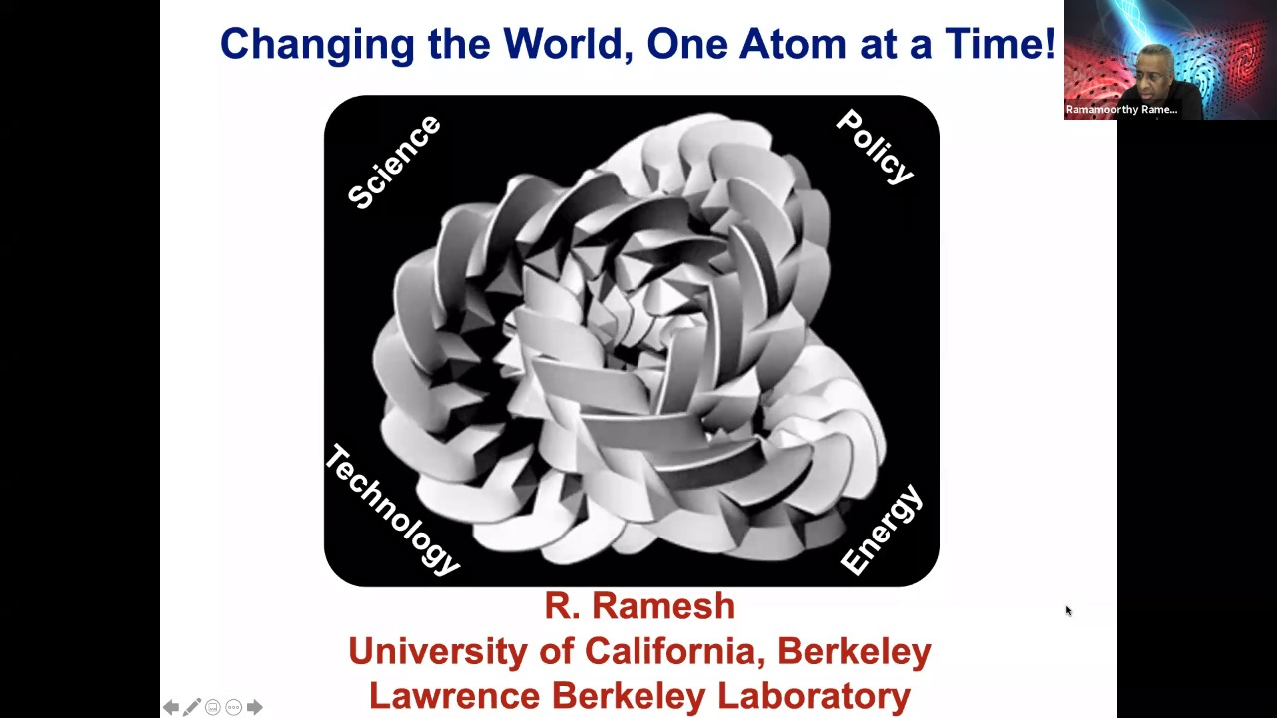

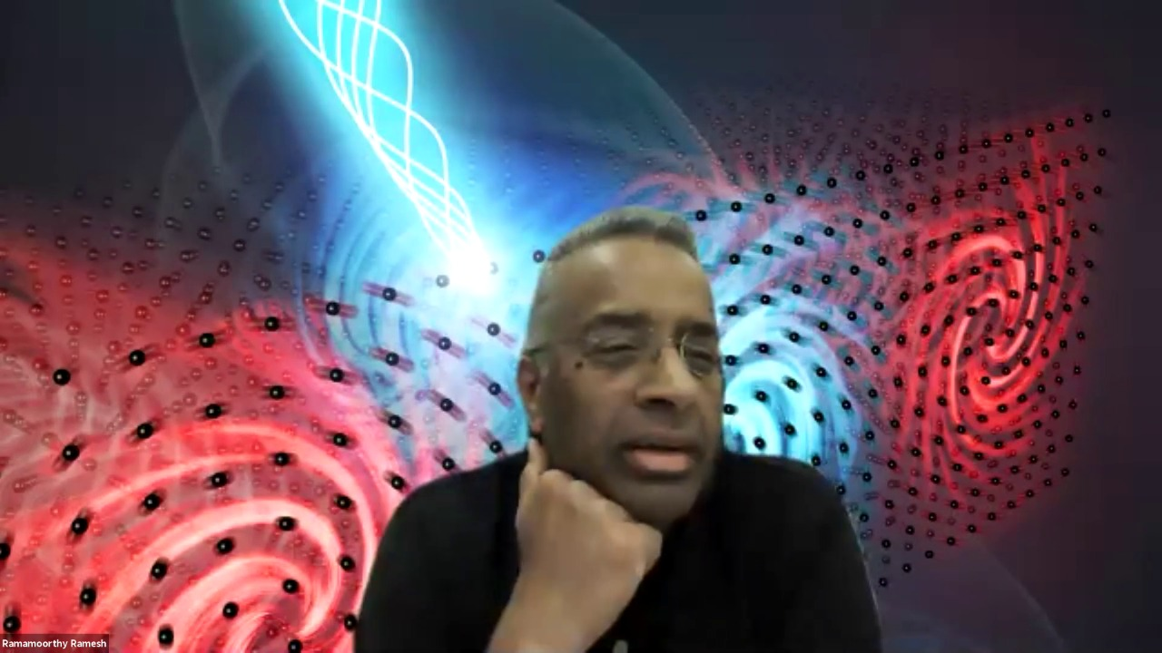

The **third** distinguished lecture was delivered on 19 July 2021 by **Prof. Martin Lee Chalfie (2008 Nobel Prize in Chemistry**), Professor, Columbia University, USA on the topic “The continuing need for useless knowledge”. The speaker is a biologist who introduced “Green Fluorescent Protein” which has drastically revolutionised the field.

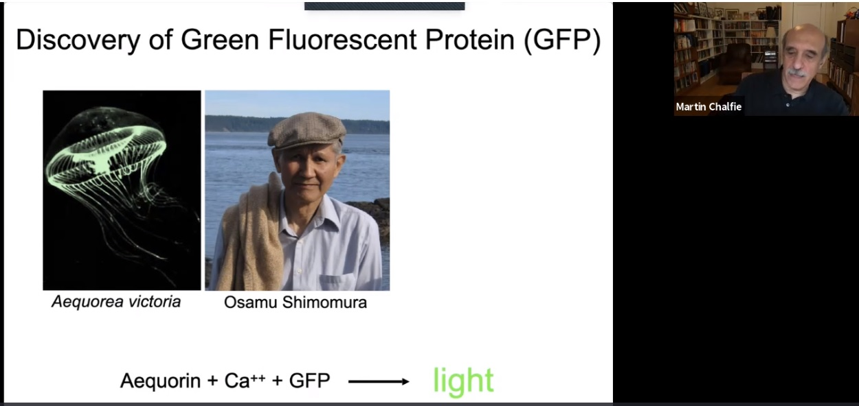

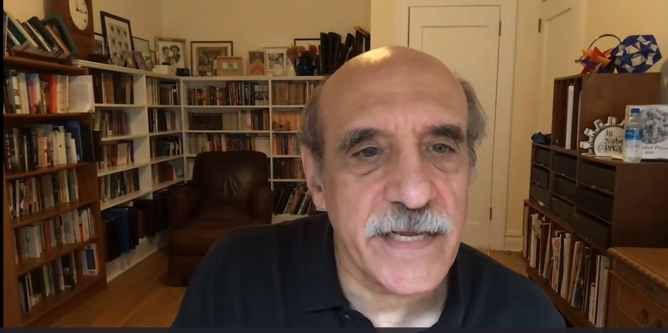

Three other Nobel lectures are already scheduled for this year in addition to the proposed distinguished lectures by speakers of international eminence.

**Lecture 4**

**Prof. David Wineland (2012 Nobel Prize in Physics)**

*Philip H. Knight Distinguished Research Chair, Research Professor, Department of Physics, University of Oregon, USA*

**Topic : Atomic Clocks**

Date & Time : Not announced, proposed for the Last week of September

**Lecture 5**

**Prof. Harald zur Hausen (2008 Nobel Laureate in Physiology or Medicine)**

*Virologist and Emeritus Professor at the German Cancer Research Center, Berlin, Germany.*

**Topic : human papillomavirus (HPV) 16 and HPV 18 and their role in Cervical cancer**

Date & Time : Not announced, proposed for the Last week of October

**Lecture 6**

**Prof. Konstantin Novoselov (2010 Nobel Prize in Physics)**

*Langworthy Professor in the School of Physics and Astronomy*

*University of Manchester, UK*

*Date & Time: Not announced, proposed for the second week of November*

**4. The practice:**

CUK’s Distinguished Lecture Series committee is constituted to arrange lectures in all the subject categories by internationally and nationally eminent scholars in addition to the Nobel lectures (around 6-10 lectures are planned by the Nobel laureates this year).

Due to the pandemic situation prevailing in the country as well as across the globe, the distinguished lectures are all planned in ONLINE mode this year. Once the situation improves, visits of Nobel laureates physically into the campus will be planned which can open up research collaboration and student/faculty exchange programmes which can eventually lift the research outlook and over all academic standards of the University to the international level.

**5. Evidence of Success:**

The live lectures conducted had participants more than 200 to 300. There were active interactions between the speakers and faculty members/research students of CUK. The lectures opened up collaboration platform for the researchers and faculty members of CUK.

**Other lectures**

**KNOWLEDGE ENRICHMENT SERIES- A series of special lectures by Professionals/Experts from Industry**

2. **Objective**

***Objective/Intended outcomes***: Management cannot be learned through theories alone, it also requires insights on how the theories can be applied in practical context and the experience shared by the experts in industry/academia provide exposure to emerging topics in their area of studies and industry experts share with students how to deal with challenges in practice.This can help the students learn about the expectations of the industry.

Underlying principles of this practice:

* Create an avenue to foster a better relationship between the industry, academia and students
* Increase the involvement of industry professionals at universities
* Expose students to the practical aspects and, to a certain extent, the know-how so that they will be able to translate theories and concepts into practice.

1. **The Context**

***Contextual factors/Challenges in designing the practice:***

* The availability of industry experts/ academicians in the midst of their professional responsibilities is a challenge. The academic system has to motivate them in an intrinsic or extrinsic way.
* To schedule and conduct series of sessions as a part of the academic program structure is also a challenge as the entire program run with a pre specified schedule of academic and non-academic activities in an academic year.
* The pandemic situation has made the availability of experts easier as such sessions can be conducted online without the physical presence of the resource persons, but the disadvantages like lack of direct interaction, personalization and communication is a challenge in terms of the effectiveness of delivery
* The generation gap is also a challenge as the Millennials and Z generation are completely different from the previous generation as they prefer a digital and visual approach of learning

1. **The Practice**

The importance of work-integrated learning is increasing in universities at the expense of purely disciplinary-based education, as employers demand industry ready graduates.In most cases, this is reflected in university-industry collaborations in post graduate research and education rather than undergraduate, with increasing links to industry found to be a positive for students in developing their employability skills and knowledge.

What were the constraints/limitations, if any, faced (in about400words)?

As stated earlier, the availability of industry experts/ academicians in the midst of their professional responsibilities is a major constraint. While some expressed their consent to deliver a speech on a particular day, sometimes, their professional commitment gets priority and hence it led to cancellation of the program. As most of the sessions are conducted online, many times network connection becomes a problem not only to resource persons but also to student participants. Sometimes due to heavy rain also students were not able to get network link and consequently they could not attend the session. However, the online sessions continued and students share their knowledge amongst them.

1. **Evidence of Success**

The feedback received from the students reveals that they were able to enrich their knowledge continuously. They further said that their confidence level increased due to the interactive approach being adopted by the Department as well as by the resource person. The resource persons not only deliver the subject but also motivate the students to do better by properly utilizing their time and online resources.

A feedback is collected from the participants after the special lecture on following parameters:

1. The additional information on the topic shared in the session
2. The relevance of the topic in the management career
3. Connecting the theory to practice
4. The industrial application of the concept discussed
5. Discussions on the contemporary practices on the topic

Although there is a variation in the feedback of students on these special lectures based on the subjective factors such as personal interest on the topic, quality of delivery and technical constraints (online lectures), and the overall feedback is found to be positive and beneficial to the student participants from an outcome perspective.

**6**. **Problems Encountered and Resources Required**

As students are required to attend regular online classes besides the special lecture, sometimes they were not able to get network connection throughout the session. The resource person also sometimes could not deliver continuously due to the connectivity issue. Once the pandemic period is over, we do hope that there would be more interaction between the students and the resource person.

**7**. **Notes (Optional)**

Any other information regarding Institutional Values and Best Practices which the university would like to include.

8. **Geo Tagged Photos**

As a proof of the special lectures conducted in 2019 and 2020, the copies of the university newsletter is attached. The screenshots brochures and schedule of the post-COVID sessions are also attached as proof.

